PADDAYA APARRI CLICKMART

A Capstone Project Proposal
Presented to the Faculty of the
College of Information and Computing Sciences
Cagayan State University
Aparri Campus

In Partial Fulfillment for the
Academic Requirement
for the degree
Bachelor of Science in Information Technology

By:
Torda, Richard E
Lubbui, Arlee Joy C
Maramag, Jellie L
Siriban, Dexter F

January 2024
Approval Sheet

This capstone project titled “Paddaya Aparri Clickmart” prepared and submitted by Richard E, Torda, Jellie L, Maramag, Arlee Joy C, Lubbui, Dexter F. Siriban in partial fulfillment of the academic requirement for the degree Bachelor of Science in Information Technology - Web Track is hereby recommended for oral examination.

Leo P. Paliuanan, PHD
Adviser

Approved on Oral Examination with a grade of 93.6 (Very Satisfactory).

PANEL OF EXAMINERS

Billy S. Javier, PHD, DIT
Chair

Julieta B. Babas, DIT Iolani A. Silvestre, MSIT
Member Member

Ferdinand S. Liquigan Aarah C. Cabalbag
Member Member

Accepted and approved in partial fulfillment of the requirements for the degree Bachelor of Science in Information Technology - Web Track.

Julieta B. Babas, DIT
College Dean

Engr. Audy R Quebral, DPA
Campus Executive Officer

Dedication

The capstone project is lovingly dedicated to our family who served as our inspirations, our strength and motivation in fulfilling our dreams and accomplishing this study successfully.

We also want to dedicate this research to our friends, who have reminded true and have always been there during our laughing and crying moments, their support is very well appreciated.

We offer this work to our hardworking and respected professor especially our capstone adviser ma’am Iolani Sivestre and sir Leo Paliuanan who taught us many ideas and help us completing this research.

And most of all, to God almighty our creator, our strong pillar, our source of inspiration, wisdom, knowledge and understanding. He has been the source of our strength throughout this academic endeavor and His wings only have we soared.

Richard
Jellie
Arlee Joy
Dexter

Acknowledgment

The researchers wished to acknowledge the following who helped them completed this project.
It is our great pleasure to express our gratitude to all those people who have supported us and contributed to make this project possible. Foremost, we must acknowledge and thank our Almighty God for the blessing, protection, guidance throughout this period. We could never have accomplished this without the faith we have in the Almighty.
We sincerely thank our parents who provided their undying love, advice, financial and moral support during the hardest time we encountered.
Special gratitude is extended to Sir Leo P. Paliuanan for his invaluable comments, suggestions, and guidance, particularly in the final stages of completing this project. We are also grateful for the opportunity to work under his guidance.
Thank you very much! We will keep on trusting in you for our future!

Table of Contents

Title Page ……………………………………………………………………………………i
Approval Sheet
Dedication
Acknowledgment
Table of Contents
List of Tables
List of Figures
Abstract

Chapter 1: INTRODUCTION
The Problem and Its Background
Conceptual Framework
Statement of the Problem
Scope and Limitations
Significance of the Study
Definition of Terms

Chapter 2: RELATED LITERATURE AND STUDIES

Chapter 3: METHODS AND PROCEDURES
Research Design
Locale of the Study
Participants of the Study
Data Gathering Tools or Instruments
Data Gathering Procedure
Data Analysis

Chapter 4: RESULTS AND DISCUSSIONS
Chapter 5: SUMMARY, CONCLUSIONS AND RECOMMENDATIONS

References
Appendices
- Communication Letters
- Hierarchical Input-Process-Output Diagram
- Data Flow Diagram
- Context Diagram
- Use Case Diagram
- System Architecture
- Database Design, Table Attributes and Domains
- Consent Form
- Questionnaire
- Curriculum Vitae

List of Tables

Table 1. Participants of the study…………………………………………………………..
Table 2. IT Expert Evaluation Tool………………………………………………………
Table 3. End-user Evaluation Tool……………………………………………………….
Table 4. Computed Mean Functionality Suitability………………………………………
Table 5. Computed Mean Performance Stability………………………………………...
Table 6. Computed Mean Cmpatability…………………………………………………….
Table 7. Computed Mean Usability……………………………………………………….
Table 8. Computed Mean Reliability………………………………………………………..
Table 9. Computed Mean Security…………………………………………………………..
Table 10. Computed Mean Maintainability………………………………………………..
Table 11. Computed Mean Portability…………………………………………………..
Table 12. Computed Mean Performance Expectancy…………………………………..
Table 13. Computed Mean Effort Expectancy………………………………………….
Table 14. Computed Mean Social Influence……………………………………………
Table 15. Computed Mean Facilitating Conditions…………………………………….
Table 16. Computed Mean Behavioral ntentions……………………………………….
Table 17. Computed Mean Perceived Effectiveness……………………………………
Table 18.Computed Mean Self-Efficacy………………………………………………..
Table 19. Computed Mean Response Efficacy…………………………………………
Table 20. Computed Mean Adoption Intention………………………………………..

List of Figures
Figure 1. Input Process and Output…………………………………………………………..
Figure 2. Agile Development……………………………………………………………….
Figure 3. Homepage…………………………………………………………………………
Figure 4. Log in Page……………………………………………………………………….
Figure 5. Admin Dashboard……………………………………………………………….
Figure 6. Seller Dashboard………………………………………………………………..
Figure 7. Add Products……………………………………………………………………
Figure 8. List of Added products………………………………………………………….
Figure 9. Customer Checkout…………………………………………………………….
Figure 10. Customer Order Details………………………………………………………

Abstract

Project Title: Paddaya Clickmart

Capstone Project Team: Richard Torda
Jellie Maramag
Arlee Joy Lubbui
Dexter Siriban

Institution: Cagayan State University at Aparri

Adviser: Leo Paliuanan, PhD
Course: Bachelor of Science in Information Technology

In our generation today, the rapid pace at how technology is transforming business is shocking, and e-commerce trends are just continuing to expand and change. This study introduces the "Paddaya Clickmart" an ecommerce web-based system designed to emerge as a leading digital marketplace fostering economic growth and community development. The results reveal that the Paddaya Clickmart aligns effectively with established criteria, garnering positive feedback across all evaluated dimensions. Users express a high degree of satisfaction and willingness to integrate the system into their daily lives. The study recommends the implementation of Paddaya Clickmart in Barangay Paddaya, emphasizing the importance of thorough training, continuous improvement, and community engagement for successful adoption.

Keywords: Clickmart, e-commerce, Digital marketplace, Technology, Business

CHAPTER I

INTRODUCTION

The Problem and Its Background

In our generation today, one of the most popular techniques for doing business locally and internationally is e-commerce. Customers all across the world now trust it not just because of the enabling technologies but also because most vendors consistently deliver high-quality services. the rapid pace at how technology is transforming business is shocking, and e-commerce trends are just continuing to expand and change. Physical stores suffered throughout the pandemic, while e-commerce companies benefited. despite the fact that consumers can now purchase in store, the trend of grocery shopping online continues to keep growing. Shopping habits have undergone a significant transformation. In addition to purchasing goods from traditional businesses, customers can shop online because of information and communication technology (ICT). These innovative methods of purchasing goods go by many kinds of e-commerce, including network shopping, online shopping, e-shopping, Internet shopping, and web-based shopping.
On these types of different platforms, it is rapidly gaining attraction as a recognized and utilized business paradigm. Many businesses are implementing websites that provide features which enable carrying out business over the Internet. It is acceptable to say that consumers are getting used to the practice of doing their shopping online. It provides users with a convenient and seamless shopping experience, allowing them to browse through a wide range of items and make purchases with just a few clicks rather than going to physical stores, which causes time-consuming visits to physical stores, limited product availability, and the inconvenience of carrying heavy bags. Additionally, customers often struggle to find specific items and compare prices, leading to a lack of efficiency and satisfaction.
Paddaya Aparri is known as one of the largest barangays of Aparri; however, the said barangay is approximately 4.5 kilometers from the public market of Aparri, and houses are far apart, which causes them hassle in purchasing goods and essential products. through visiting a physical store, which is also time-consuming when traveling. Nevertheless, Paddaya Aparri also has their local products that remain undiscovered and difficult to sell because most of their products go their location is far from their public market, making it challenging to import their products. One of their solutions for selling their products is to sell them manually resulting in a prolonged advancement of their sales.
To address the issues mentioned above, the researchers decide to create a web-based system named “PADDAYA CLICKMART” To help the barangay's residents in marketing their products and to support customers in finding their basic needs. Both of buyers and sellers are going to benefit greatly from this type of idea. sellers can showcase their unique products; Buyers as are going to discover it straightforward to look for and buy products in their barangay. For both sides, it will be a more aware and practicable choice.
The goal of this project is to create a convenient online purchasing experience for consumers. Reduce the need for travel so that buyers can save time. They can quickly search for products and make purchases in a matter of minutes and lastly Make shopping accessible to a wider audience by eliminating geographical limitations. Buyers don't need to go to physical stores because they can access the platform from anywhere and make purchases. Throughout the development phase, Proponents will do extensive user research and testing throughout the development process to ensure that the system meets the demands of the seller and the buyer. User input will be included in the system's design and operation to ensure that it is user- and mobile-friendly. The initiative's results will give users additional information.

Conceptual Framework

The conceptual framework showed and indicated the flow of the system. This helped the render or the user to understand how it was processed.

INPUT

- Practices, policies and problems of the system
- Users
Requirements
- ISO 2510:2011
Software quality evaluation
- Technology Acceptance Model

PROCESS
- Data collection and Analysis of practices, policies, issues and problems.
- Design and development of SDLC method (Agile Development)
- Assessment of the system using ISO 25010:2011 and TAM
- Data Analysis of Interpretation on the Assessment of the system

OUTPUT

PADDAYA APARRI CLICKMART

FEEDBACK

Figure 1: Research Paradigm

The diagram shows the input-process-output cycle. The input includes Practices, policies and problems of the system in the agency, Data set from different modules facilitates online transactions, software quality and Technology acceptance model.
However, In the process, it involves the Data collection analysis of practices and issues and problems, Software development using Agile and Assessment of the system using ISO 25010:2011 and Technology Acceptance Model. Lastly, the output of the study will be the operational system implemented in Paddaya, Aparri.

Statement of the Problem

The main objective of this study is to develop a web-based Paddaya Clickmart system for Paddaya, Aparri.
Specifically, the project aims to address the following:
- What are the current policies, issues, and problems encountered in the current system?
- What system could be developed based on the result of the assessment?
- What is the extent of compliance of the developed system as viewed by the IT Expert using the ISO 25010:2011 standard in terms of:
  - Functional stability
  - Performance efficiency
  - Compatibility
  - Usability
  - Reliability
  - Security
  - Maintainability and
  - Portability

- What is the level of acceptance of the end-user on the developed system using the Technology Acceptance Model in terms of:
  - Performance Expectancy
  - Effort Expectancy
  - Social Influence
  - Facilitating Condition
  - Behavioural Intention
  - Perceive Ease of Use
  - Perceive of Usefulness
  - Self-Efficacy
  - Response Efficacy
  - Adoption and Intentions

Scope and Limitations

This study focuses on Paddayanos, Aparri Clickmart, a web-based platform that targets the residents of Paddaya as both sellers and buyers. On the website, where they may publish and view their items and pricing, the seller and buyer will register. Additionally, it will include ratings and reviews left by users who have completed the transaction.
However, this study is mainly focused on the barangay authorities, and three end users: the admin, who is only allowed to update and maintain the records in the system, the seller, who stores the products they intend to sell, and the buyer, who will enquire about the products they like. Only Paddaya Clickmart registered sellers are allowed to post their products in the auction area. Different categories were made for the items in order to improve system structure and reduce the need for the search button.

Significance of the Study

The study is intended several groups of people who this system may be beneficial to. The following will benefit from the study's outcome:
Organization- The system helps organization so that they can introduce their products that came from their own natural resources. With this, their organization will recognize in different part of the world and this makes their economy grow.
Seller- The system expands a seller's market because the number of clients who can physically visit their area or location is no longer a constraint on their ability to make a profit. All geographical restrictions are lifted because they can sell across cities, states, and even international borders. It can also make their products known not only in their local area but online the whole world.
Customers- Through this system buyer can purchase goods whenever it is convenient for them to buy online. Clickmart is available at any time, unlike traditional brick-and-mortar stores, which typically operate within set hours. The availability of online purchasing around-the-clock is a huge perk. No matter how far Paddaya is buyer can purchase anytime and anywhere.
Future researchers - Researchers who intend to make any relevant studies precisely the standard that underlie the Bachelor of Science in Information Technology will find this system to be a beneficial reference.

Definition of Terms

Buyers - people who make purchases through the system. They are the customers who purchase goods or services from the system.
Clickmart- a website that consumers buying for products and services.
DAYA - is an Ilocano word that refers to the eastern part of a city or town.
Feedback – refers to information directly from clients about their pleasure or dissatisfaction with the system.
ICT - (Information and Communication Technology) refers to use of technology regarding information management and communication.
Internet – global network of interconnected of networks that connects computer all over the world.
Paddayanos – residents of Paddaya aparri
Public market- marketplace where goods, products, or services are bought and sold by customers.
Sellers- users has the ability to post and store their products through the system.
User friendly – a system or mechanism that is simple to operate or comprehend.
Web-based – software that is accessible using web browser and internet connection
CHAPTER II

RELATED LITERATURE AND STUDIES

This chapter provides an overview of relevant studies and literature that the researcher has considered to underscore the significance of the study. Additionally, it offers a synthesis of the current state of the art to facilitate a comprehensive understanding of the research.
The internet has emerged as a platform providing marketers with opportunities to enhance the value of products and services. The unprecedented growth and increasing popularity of the internet and the World Wide Web serve as crucial factors in attracting more consumers and businesses to embrace the advantages of Electronic Commerce (E-commerce). E-commerce is defined as any business transaction where parties interact electronically instead of through physical exchanges or direct contact (Anders Johansson, 2004). According to reports, 58 percent of internet users make online purchases every week (Kemp, 2021). This transformation has revolutionized traditional commerce, leading to increased sales and the exchange of goods and information. E-commerce is not merely a standalone technological entity; rather, it represents a convergence of technologies where applications, processes, and business strategies are essential for conducting electronic transactions. The ability to access goods and services with a simple mouse click is reshaping the global business landscape.
According to (Bodini & Zanoli, 2017), the advancement of online food commerce holds significant importance, particularly in remote areas where physical accessibility is a challenge for consumers. In such cases, the viable solution is to opt for online purchases. It is noteworthy that the promotion of short supply chains for local products, exemplified by agricultural trade conducted through the Internet, plays a crucial role. The Internet has evolved into a multifaceted tool for social interaction, shopping, and staying informed. Despite the exponential growth of online shopping, the true potential of the internet is still unfolding, especially with the proliferation of new electronic devices capable of accessing it. It is observed that while certain products thrive in the online market, others continue to fare better through local brick-and-mortar stores (Payaro A., 2016).
Traditional marketing has been eclipsed by digital marketing. The skills gap in digital marketing is impacted by several factors. Online advertisements are becoming more common. Digital marketing's perceived value by businesses can be categorized. Utilizing digital marketing platforms to satisfy client objectives necessitates an integrated strategy. Businesses must first comprehend the lifestyles of their clientele in order to succeed in this new market. Despite a lack of funding to keep up with technological advancements and take advantage of online development, digital marketing has developed into a platform for online advertising for small business owners. Digital marketers are starting to pay attention to social media advertising. It is anticipated that social advertising spending would increase in the upcoming years due to the potential market share gains that social media marketing could provide for online marketers. (Alreany C. Tabuena, 2022)
(Kathy Gramling, May 2021) According to a study, 80% of U.S. consumers are still altering their shopping habits. Currently, 60% are making fewer visits to brick-and-mortar stores compared to the period before the pandemic, and 43% are increasingly opting for online shopping for products they would have traditionally purchased in physical stores. The Covid-19 pandemic has brought about a significant realization that, for many individuals, geographical location has become less influential, as long as there is access to the internet. This newfound flexibility has empowered more consumers to relocate from urban centers. Recent data from the Index reveals that 26% of respondents are planning to reside in less densely populated areas, reflecting an increase from 22% in April 2020. Similarly, in South Asia, there has been substantial growth in E-commerce in recent years; however, it is noted that the region has yet to fully realize its E-commerce potential (Perego V., 2019). Within the context of E-shopping in Pakistan, numerous stores have developed websites allowing customers to shop online and facilitate payments through debit/credit cards. Regrettably, there exists a general lack of confidence among the Pakistani public regarding the goods presented to them online. Despite this, Pakistani adults display adaptability and an increasing involvement in online shopping, particularly in the realm of online food orders (Dost M. K., 2015). Despite limited awareness and trust issues surrounding E-shopping within Pakistani communities, individuals continue to perceive it as a convenient shopping avenue (Sulaiman A., 2007).
According to (Sabine Durand-Hayes, 2023), a notable shift toward online shopping emerged initially during lockdowns and continued as many individuals transitioned to working from home. Various trends in this digital consumption shift include online shoppers actively seeking the best prices, opting for healthier choices, and demonstrating a preference for eco-friendly practices by supporting local businesses when possible. A significant revelation from the report indicates that consumers anticipate a lasting change in their shopping behavior even after the pandemic subsides. Despite Consumer Electronics being initially considered non-essential, the "new normal" marked by widespread online classes and remote work has led to a 7.4% increase in the sales of electronic products (Euromonitor, 2020). Home entertainment electronics, in particular, have become essential for providing entertainment during lockdown periods. Notably, there has been a surge in consumer electronic brands entering the online retail market, often offering affordable products tailored for consumers. Online sellers are also catering to experts and enthusiasts by providing a diverse range of mobile gadgets and accessories (Law, 2019).
As seen in (Chakraborty, 6 June 2019) Filipino consumers exhibit varied purchase intentions influenced by their needs, attitudes, and perceptions towards products or brands. A conclusion drawn by Meyer, Koch, and Schewe (Julia Koch, 2020) suggests that media, including social media, significantly impacts the purchasing intentions of generations Y and Z. Data from Kemp (February 2021) indicates that 77.2% of Generation Z individuals aged 18-24 purchased products online in the past month. According to Kemp's statistics (2021), Filipinos spend an average of 10 hours and 56 minutes on the Internet, encountering various enticing advertisements encouraging online purchases from platforms like Shopee and Lazada.
The prevalence of online shopping activities has witnessed exponential growth in recent years. In this context, e-shopping environments play a significant role, allowing users to delegate buying and selling responsibilities to agents instead of navigating e-shopping independently (Braz). Filipino online shoppers are active users of social media platforms, with Facebook being widely utilized. A substantial portion of them engages with social media daily, with one-third spending three or more hours on these platforms. Research indicates that social media marketing has a positive impact on e-shopping customers concerning online visibility, social media engagement, integration, activities, and experience. Furthermore, the study suggests that brand owners should focus on the timing and consistency of posts to effectively grow a social media audience (Tseng-Lung Huang, 2017).
As demonstrated in (Thinkwithgoogle, 2018) In an age where time is a rare commodity, shopping online provides massive time savings to the consumer. Since 63% of consumers start their shopping journey online, it makes sense to be able to buy where you already are no need to head out, shop in-store, wait in line, and then journey back home when you can access a greater product variety at a lower price from the comfort of home. Researcher have found another important attribute that is price of the product or services and discount, as they perceive while shopping online, they get items in lower prices and the get better discounts while shopping online. (Dipti Jain, 2014).
As per (Suwunniponth, 2014), the study's findings indicate that factors related to website quality, perceived ease of use, and perceived usefulness exert influence on trust in online shopping. Trust, in turn, influences the attitude towards online purchases, with both trust and attitude towards online purchases shaping the intention to make online purchases. Another study by (Al-Debei et al., Mutaz M Al-Debei, 2015) suggests that consumer attitudes toward online shopping are determined by trust and perceived benefits. Trust is seen as a result of perceived web quality and electronic Word of Mouth (eWOM), and the latter is influenced by perceived web quality. Consequently, trust and perceived benefits emerge as critical predictors of consumer attitudes toward online shopping, as per the study's results. Additionally, the authors found that higher levels of perceived web quality led to increased trust in an online shopping website. Perceived web quality was identified as a direct predictor of trust, and it positively and significantly influenced perceived benefits. The study also revealed that 28 percent of the variation in online shopping attitudes was attributed to perceived benefits and trust.
As outlined by (PROF. Mary Grace Delelis, 2019), the results of her study underscore the importance of considering online shopping seriously for both online platforms and shoppers. The survey conducted revealed a positive attitude and behavior towards online shopping, even among consumers with limited weekly allowances who still engage in online shopping. The study highlights that, from the respondents' perspective, various online shopping platforms offer tangible advantages such as reducing the time spent on sorting through options, facilitating better buying decisions, minimizing the time spent on purchases, and providing increased opportunities to explore alternative products. As per (Bacay, 2022) Due to the COVID-19 pandemic, the Philippines' E-Commerce market has grown at an unprecedented rate, compelling customers to shop online. Both physical establishments and e-commerce platforms saw a cascading effect as a result of the shift in consumer behavior. The study concentrated on Shopee's major online purchasing occasions, which position the platform as the top online shopping application in the Philippines by 2020, in light of the impact on the aforementioned sector.
The overall results suggest that online shopping's availability 365 days a year, its non-stop nature, and its environmental friendliness contribute to its positive trajectory. Consumers can fulfill their desires with a simple click of the mouse without leaving their homes or relying on transportation. As a result, the study anticipates that online shopping will experience significant growth in the years to come.
The most important factor influencing technological intention is perceived usefulness. Considered utility has a substantial impact on the desire to use an information system. This is due to the primary goal of Customers should be aware of how to evaluate perceived value when making purchases online since this might lead to favorable outlook for interest in online purchases. meantime, has a detrimental impact. due to variations in each subject's socioeconomic condition, on interest in online purchases, or even qualities that may influence how risk is viewed. Additionally, the Perceived ease of use experienced by customers, the greater interest in making an online purchase. This increases the interest in purchasing. If customers sense the
Because internet transactions are simple, people will have a more favorable opinion of online shopping. (Ellitan, June 2022).
E-commerce has been acknowledged to have a favorable impact on businesses across the board that support the expansion of the Philippine economy since its inception. Moreover, it provided undergraduates with a chance to seek employment and enhance the Philippines' employment potential. Because of its dynamic characteristics, Filipino customers may surf websites more quickly and easily than they could with the outdated methods used in the commerce business. This study established the relationship between technology and labor productivity and e-commerce through the use of cross-sectional data and the Pearson Correlation Coefficient. (Gabinete, 2022)

Chapter III
METHODOLOGY

Research Design

The quantitative research design used in this study. In order to gain insights into the customer/user, a structured questionnaire was utilized in gathering data. Frequency, weighted mean, and percentage tables were used.
Agile Development was utilized in this research and it helped the team in managing work on the project more effectively and at the same time deliver a quality product to the customer by frequently giving updates and useful software. Also, in order to be able to deliver satisfaction to the customer, frequent interaction between the developers, the customer, and the testers was done.
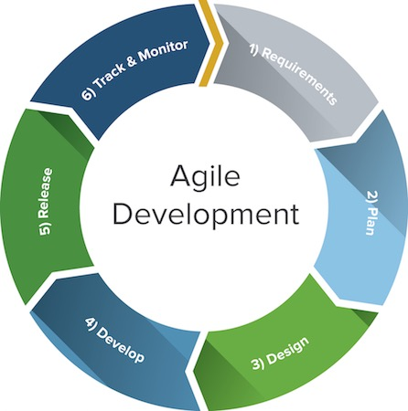
Figure 2: Agile Development

- REQUIREMENTS
- In this phase all the that are going to be needed in developing a system are ensured and researches made. Software and hardware requirements are also ensured in this phase in order for everything to be ready for the next phase.
- PLAN
- This phase is very crucial in software development because once it fails it is like you are planning for your failure. The scope of this phase is very wide because you will not just plan how you create the system but also for possible problems and mitigation plans are made in advance.
- DESIGN
- In this phase the interface and designs of the system are decided. User interfaces should be something appealing to the eye but not too complicated for new users.
- DEVELOP
- In this phase the actual coding of the operating system is commenced.
- RELEASE
- This phase will be the implementation of the project /operating system unto the partner agency as well as testing
- TRACK & MONITOR
- After releasing the system into agency, errors are checked and iterations are made.

Locale of the Study
The study's target population is the sellers and customers of the web-based clickmart intended for Paddayanos. The system was launched at Paddaya, Aparri, Cagayan and was made available to customers within Paddaya Aparri.

Participants of the Study
The participants of the study were selected based on residence, age (18-65), basic computer literacy, and a history of online purchases. To capture insights from local sellers, inclusion criteria considered active engagement in local businesses. Exclusion criteria ensured the exclusion of IT experts while maintaining representation from 30 customers, 10 local sellers, and 5 barangay kagawad.
Table 1. Participants of the study
Participants | frequency | Percentage
IT professionals | 5 | 5.00
Sellers | 10 | 33.33
Barangay Officials | 5 | 5.00
Customers | 30 | 60.00
Total | 50 | 100.00

Data Gathering Tools or Instruments

To gather reliable data or information and come up with the system requirements and desired output of system, the researchers used the following instruments.
Interview/Observation- in gathering information the interview/observation is one of the precise tools for it. Interviewing through question and answer physically and at the time and observing helped us understand the problem of the organization. The researchers used an interview/observation to gather data on the activities, policies, and opinions of the people involved in the computerization of the system.
Internet- the most common source of information is the Internet; it is the limitless library. This is used by the researchers in order to have relevant information.
Questionnaire - For the assessment of the system. The proponents used 2 sets of questionnaires for the evaluation and assessment of the proposed project. The questionnaires are as follows; (a) ISO 25010:2011 Software quality standard and (b) Technology Acceptance model.

Data Gathering Procedure

In gathering data, a step-by-step process followed by the researchers in order to derive the desired outcome.
- Formal communication was be made to the target agency of the project.
- Upon approval from the head office, approved communication was extended to the agency,
- The researchers conduct a personal visit to observe their processes of SOP’s
- The project objectives were presented, purpose of the study and its benefits to the participants. In order to support the validity of the data. information was gathered through interviews. Prior the development of the system.
- The researchers also searched over the internet, books and tutorials that are conducive in developing the proposed system. After integrating all the modules and processes in one system in place, the system would now be subjected for initialization, series of test and implementation. Researchers formally asked the end users to assess the develop system.
- Questionnaires from ISO 25010:2011 and the technology acceptance model distributed to the end users to evaluate and assess the develop system. Purposive sampling was used by the proponents to choose specific people within the population.
- Data were tabulated; analysis of these would be made. The results would be discussing and presented.

Data Analysis

The data gathered in this research will then be counted and organized in order for the results to be analyzed and interpreted. The researcher used descriptive method, frequency counts, percentages and weighted means. Also using Microsoft Excel in tabulating collected data from the end users and IT experts.

The data gathered through the questionnaires will be judged based on its quality below:
Numerical input | Scale Range | Descriptive Interpretation
5 | 4.21-5.00 | Very High Extent
4 | 3.41-4.20 | High Extent
3 | 2.61-3.40 | Moderate Extent
2 | 1.81-2.60 | Low Extent
1 | 1.00-1.80 | Very Low Extent
Table 2. For ISO 25010:2011 IT Expert Evaluation Tool

Table 3. For Technology Acceptance Model End-user Evaluation Tool
Numerical input | Scale Range | Descriptive Interpretation
5 | 4.21-5.00 | Strongly Agree
4 | 3.41-4.20 | Agree
3 | 2.61-3.40 | Neutral
2 | 1.81-2.60 | Disagree
1 | 1.00-1.80 | Strongly Disagree

Likert Scale - It functions by having a person complete a questionnaire that requires them to indicate the extent to which they agree or disagree with a series of statements.

Weighted Mean - The proponents will be used the mean to measure the ratings of the respondents regarding on the performance and effectiveness of the proposed system.

The proponents will be using the mean to measure the ratings of the participants regarding the evaluation and assessment of the develop system. The formula in getting the mean is presented in the figure below:

Weighted Mean (WM) = ∑fx1+x2 …. + xn/N

Where:
F (x1+x2+ …. xn)N = Represents the summation of all means of each criterion.
N = Represents total number of participants
Percentage would be used to determine the qualitative ratio of the data gathered, also, is the number or ratio expressed as a fraction pf 100.

Percentage(P)=FN*100
F= Frequency of a numeric rating for some give criteria
N = Represents total number of participants
Chapter IV

RESULTS AND DISCUSSIONS

- What are the current policies, issues, and problems encountered in the agency?
Paddaya Aparri is known as one of the largest barangays in Aparri; however, the said barangay is approximately 4.5 kilometers away from the public market of Aparri, causing inconvenience in purchasing goods and essential products. Visiting a physical store is also time-consuming when traveling. Paddaya Aparri has various products that remain undiscovered and difficult to sell because most of their products are located far from the public market, making it challenging to distribute their products. One of their solutions for selling their products is to sell them manually.

- What system could be developed based on the result of the assessment?
This system will be a big help for sellers and buyers. It will be easy for the customers to look for an item and for the sellers to sell their items in their barangay. It will be a more viable and smart option for customers and sellers.

Home Page
Figure 3: Homepage

This figure shows the initial point of user's interface as they browse the paddaya clickmart. This showcases the main features of the system,
Login/Sign Up - This section invites users to either create a new account or access an existing one. This prioritized placement emphasizes the importance of user accounts for a personalized and secure experience.
Search Bar - Empowers users with a dedicated search button, enabling efficient product discovery. Users can input specific queries to quickly find the products they are looking for, enhancing overall usability and convenience.
All Categories - Displays various product categories, each containing specific items uploaded by sellers. This structure enhances user navigation, allowing them to easily locate products of interest within designated categories.
Announcements - Showcases daily announcements posted by the admin, ensuring users stay informed about important updates, promotions, or any other noteworthy information relevant to their shopping experience.

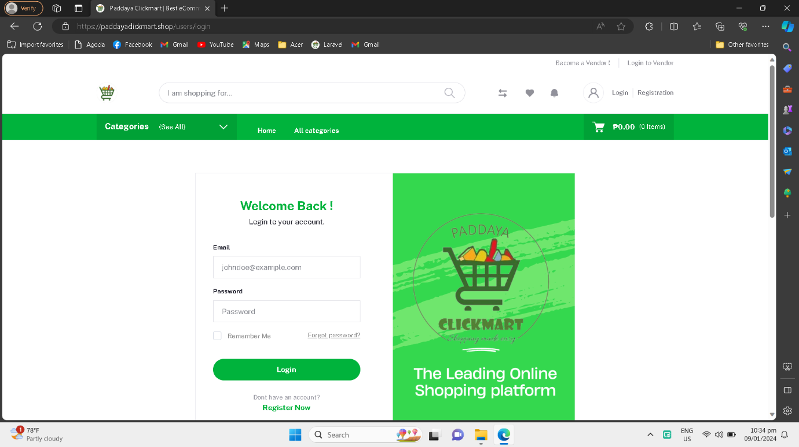
Log in page
Figure 4: Log in Page

This feature serves as serves as the gateway for users to access their accounts on Paddaya ClickMart. This crucial interface requires users to provide their registered email and password, offering a secure and personalized entry point. The straightforward design emphasizes simplicity and efficiency in the login process, ensuring a smooth transition for users seeking to engage with their accounts. By prompting users to enter the specific credentials used during registration, the login page enhances security and reinforces a user-friendly approach to account access.
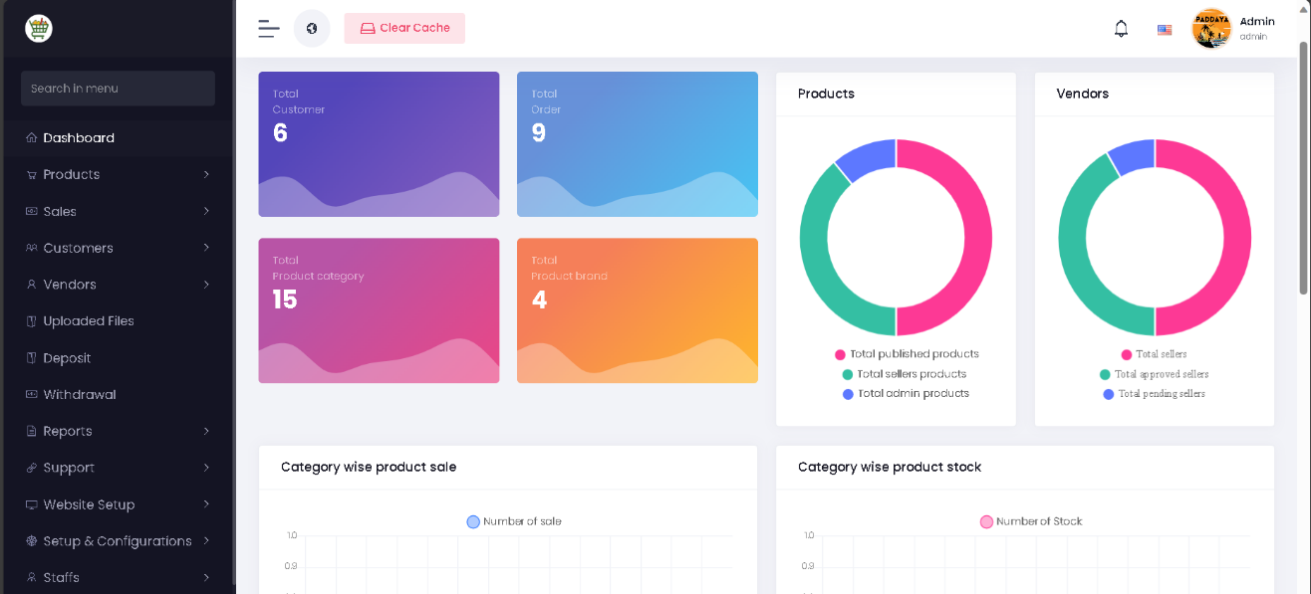
Admin dashboard
Figure 5: Admin dashboard

The admin dashboard is an exclusive panel accessible only by the administrator, providing comprehensive control over the Paddaya ClickMart system. The sidebar presents a range of features allowing the admin to monitor and manage various aspects of the platform, ensuring efficient system oversight and performance optimization.

Key components of the admin dashboard include:
Sidebar Navigation - Grants access to diverse features enabling the admin to monitor and manage different facets of the system. This structured sidebar enhances ease of navigation, allowing the admin to swiftly navigate between functionalities.

Main Dashboard - Displays essential metrics such as the total number of users and products uploaded. This centralized overview empowers the admin to grasp the platform's performance at a glance, facilitating informed decision-making and strategic management.

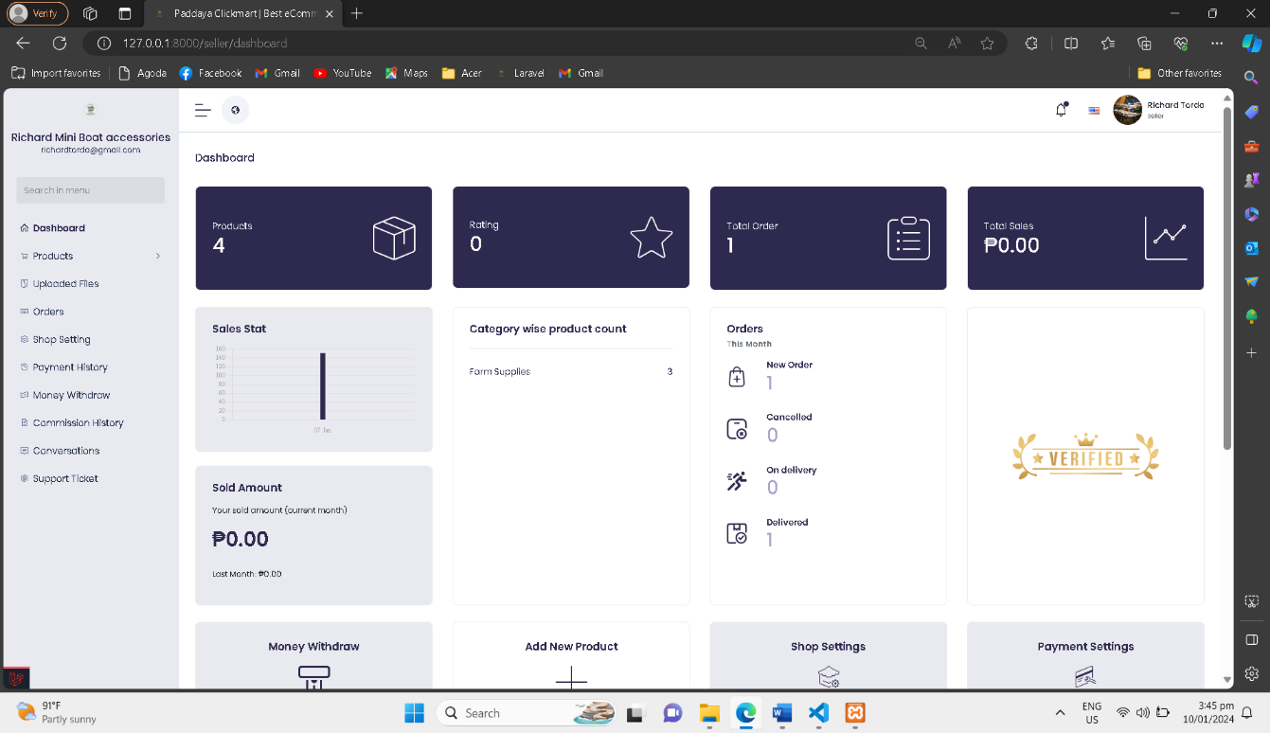
Seller Dashboard
Figure 6: Seller Dashboard
The Seller Dashboard is a distinct interface only for sellers on Paddaya ClickMart, offering a specialized set of functionalities for store and product management. Unlike the admin dashboard, the seller dashboard focuses on empowering individual sellers with tools to enhance their store's performance. From Sidebar Navigation Provides specific options for sellers to manipulate their stores and products. The sidebar includes dedicated sections for updating products, managing stores, handling orders, and monitoring payments.

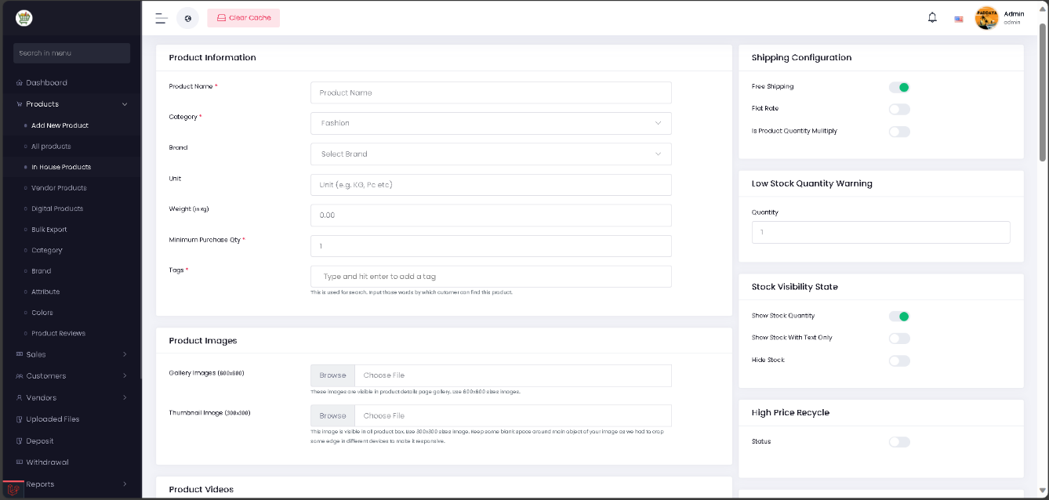
Add Products
Figure 7: Add Products

This phase is dedicated to product addition, guiding sellers through the process of inputting comprehensive product details. Sellers are prompted to fill all necessary fields, ensuring a thorough and informative representation of their products on the platform. This meticulous approach contributes to a high-quality product catalog.

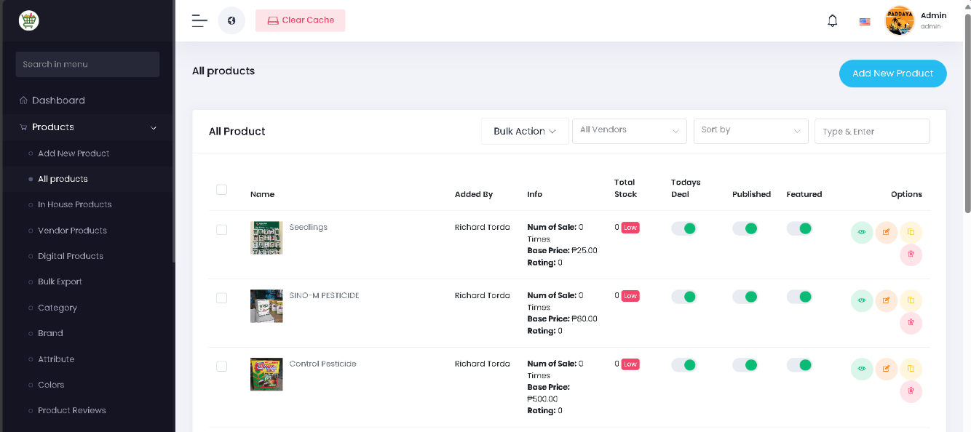
List of Added products

Figure 8: List of added products

This figure displays the list of products uploaded by the seller. Seller can view, edit or remove products as needed. This feature helps the sellers in maintaining an organized and up to date product catalog. Within the Seller Dashboard, the "List of Added Products" feature provides a comprehensive view of all products added to the seller's inventory. This functionality enables sellers to manage their product catalog efficiently, with options to add, edit, and delete products to keep information and inventory up-to-date.

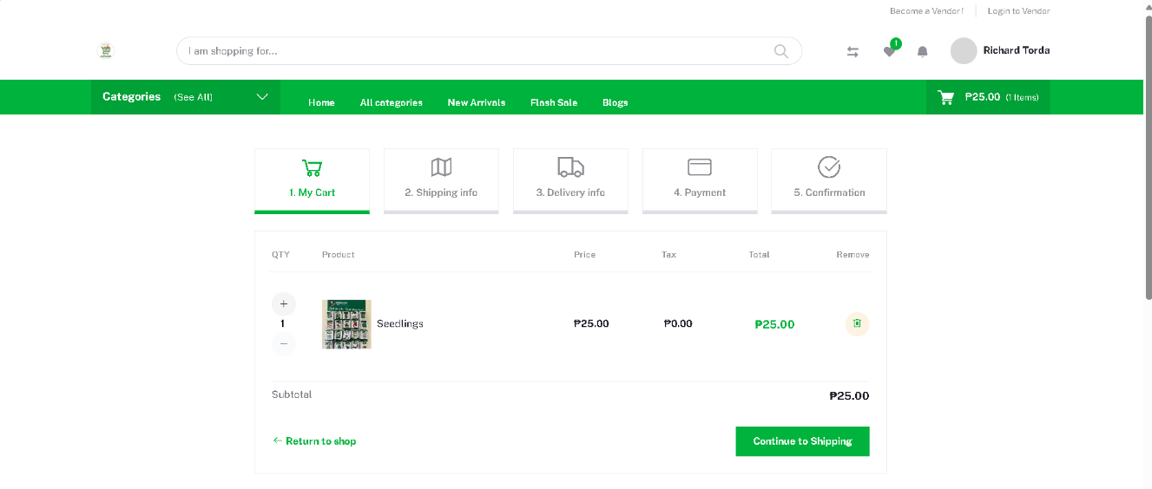
Customer Check out
Figure 9: Customer check out

Customer check out- In this phase shows the customer Interface where the customer wants to purchase products. User must follow the 5 stages to checkout their orders by adding shipping information, delivery information, payment method and confirmation of all credentials added

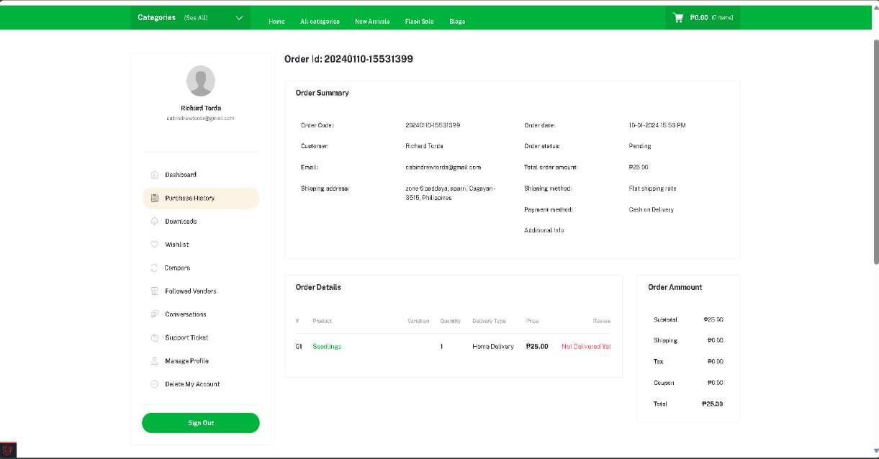
Customer Order details

Figure 10: Customer Order details

This phase shows the order details, after the customer make purchase the orders details show the Order summary, shipping Information, delivery status and Payment status.

Evaluation Results

Summary assessment of the system in terms of its compliance to ISO 25010:2011

In this section, all the summary of the evaluation through IT experts, we compute the rate /average of each user/admin and IT expert that how the developed system is functional, effective and useful.

Functionality Suitability | Weighted Mean | Interpretation
1. The information is effective and helpful to complete what is needed. | 4.20 | High Extent
2.The system/website has all the functions and capabilities needed. | 3.60 | High Extent
3. The system/website provides error messages /notifications that are clearly understandable. | 3.80 | High Extent
OVER ALL WEIGHTED MEAN | 3.87 | High Extent
Table 4. Computed Weighted Mean on the Assessment of the Extent of Compliance to ISO 25010:2011 Software Quality with respect to Functionality Suitability

The table shows the functionality suitability of the system indicates a high extent of effectiveness as evidenced by a weighted mean score of 4.20. Furthermore, the system or is deemed highly suitable since it possesses all the necessary functions and capabilities, attaining a weighted mean score of 3.60. Additionally, the system's provision of clear and understandable error messages or notifications, reflected in a weighted mean score of 3.80, further contributes to its overall high level of functionality.

Performance Stability | Weighted Mean | Interpretation
1.The same function (e.g. adding, viewing, editing, uploading, printing, posting and many more) be used by more than one person at the same time with efficiency. | 4.40 | Very High Extent
2. The software/website support group’s devices with application upgrades or browser updates. | 4.20 | High Extent
3. The software/website or project forms, tables, data grids or webpage contents are being displayed and viewed real-time without carrying runtime errors. | 4.40 | Very High Extent
OVER ALL WEIGHTED MEAN | 4.33 | Very High Extent
Table 5. Computed Weighted Mean on the Assessment of the Extent of Compliance to ISO 25010:2011 Software Quality with respect to Performance Stability

The performance stability of demonstrates a very high extent, with a weighted mean score of 4.33. This is evidenced by features such as simultaneous use of functions by multiple users (4.40) and support for device updates (4.20). Additionally, real-time display of forms, tables, and webpage contents without runtime errors contributes to the overall high-performance stability of the system (4.40).

Table 6. Computed Weighted Mean on the Assessment of the Extent of Compliance to ISO 25010:2011 Software Quality with respect to Compatibility
Compatibility | Weighted Mean | Interpretation
1. The software/website is compatible with input/output standards, Programming language and Database standards. | 4.00 | High Extent
2.The system/website is compatible and responsive to any device in any type of resolution. | 4.20 | High Extent
3. The system/website is accessible and compatible on Windows, Mac and open-source platforms. | 4.20 | High Extent
OVER ALL WEIGHTED MEAN | 4.13 | High Extent

The table demonstrates a high extent of compatibility, scoring 4.13 in the overall weighted mean. It aligns with input/output standards, programming languages, and database standards (4.00). Additionally, the system is highly compatible and responsive across various devices and resolutions (4.20), as well as accessible on Windows, Mac, and open-source platforms (4.20).
Table 7. Computed Weighted Mean on the Assessment of the Extent of Compliance to ISO 25010:2011 Software Quality with respect to Usability
Usability | Weighted Mean | Interpretation
1. The system/website can operate 24/7 even outside human interaction. | 4.20 | High Extent
2. The system/website menus, links, and buttons are working properly on specified use. | 4.20 | High Extent
3. The system/website allows me to efficiently complete any process or transaction with faster turn-around. | 4.00 | High Extent
OVER ALL WEIGHTED MEAN | 4.13 | High Extent

The usability assessment of the system indicates a high extent, with an overall weighted mean of 4.13. Notably, the system is designed for continuous operation 24/7, even without human interaction (4.20). Furthermore, menus, links, and buttons function correctly for specified use (4.20), contributing to efficient completion of processes with faster turn-around (4.00).

Table 8. Computed Weighted Mean on the Assessment of the Extent of Compliance to ISO 25010:2011 Software Quality with respect to Reliability
Reliability | Weighted Mean | Interpretation
1. Information provided/posted on the system/website are current and reliable. | 4.00 | High Extent
2. The information provided by the system/website is easy to understand. | 4.40 | Very High Extent
3. Clear information (such as online help, on-screen messages, and other documentation) are present and provided with the system/website. | 4.40 | Very High Extent
OVER ALL WEIGHTED MEAN | 4.27 | Very High Extent

The reliability assessment for the system/website indicates a very high extent with an overall weighted mean of 4.27. The information presented on the system/website is both current and reliable (4.00). Additionally, the provided information is not only easy to understand but also supplemented by clear documentation, including online help and on-screen messages (4.40). In summary, the system/website demonstrates exceptional reliability, earning a very high overall rating.

Security | Weighted Mean | Interpretation
1. The system/website security features covers Admin System access, Feature access, Database field access, Master file changes and Standing data. | 3.60 | High Extent
2. The reports produced by the system/website are detailed and protected by access levels. | 3.60 | High Extent
3. Each user have a personal password, users have different permission levels and security management system logs, data and security of the database. | 4.00 | High Extent
OVER ALL WEIGHTED MEAN | 3.73 | High Extent
Table 9. Computed Weighted Mean on the Assessment of the Extent of Compliance to ISO 25010:2011 Software Quality with respect to Security

The security assessment indicates a high extent, with an overall weighted mean of 3.73. Notably, security features cover various aspects such as Admin System access, Feature access, Database field access, Master file changes, and Standing data (3.60). Additionally, the reports generated by the system/website are both detailed and protected by access levels (3.60). Moreover, individual users have personalized passwords, diverse permission levels, and the security management system logs, ensuring the security of both data and the database (4.00).

Table 10. Computed Weighted Mean on the Assessment of the Extent of Compliance to ISO 25010:2011 Software Quality with respect to Maintainability
Maintainability | Weighted Mean | Interpretation
1. The system/website is easy to maintain even without technical support. | 3.80 | High Extent
2. The system/website provides administrative control panel that allows information to be updated real-time in its windows forms, tables or web pages. | 3.40 | High Extent
3. The system/website has a comprehensive & user-friendly that includes help & support and user’s guide. | 3.80 | High Extent
OVER ALL WEIGHTED MEAN | 3.67 | High Extent

The maintainability evaluation indicates a high extent of user-friendly features, with an overall weighted mean of 3.67. Notably, the system is considered easy to maintain independently (3.80), provides an administrative control panel for real-time updates (3.40), and offers a comprehensive, user-friendly experience with help and support features (3.80).
Portability | Weighted Mean | Interpretation
1. The system/website can be transferred to any workstation and/ or webhost or any platform. | 4.20 | High Extent
2. The system/website is accessible at all types of devices or workstation. | 4.00 | High Extent
3. The system/website can be easily transferred without fear of system failure and/or data loss. | 3.60 | High Extent
OVER ALL WEIGHTED MEAN | 3.93 | High Extent
Table 11. Computed Weighted Mean on the Assessment of the Extent of Compliance to ISO 25010:2011 Software Quality with respect to Portability
The assessment demonstrates high portability with an overall weighted mean of 3.93. It can be easily transferred to any workstation, web host, or platform (4.20) and is accessible across various devices (4.00). Additionally, the transfer process is smooth, minimizing concerns about system failure or data loss (3.60).

Summary assessment of the system in terms of its compliance to
Technology Acceptance Model (TAM)

Table 12. Computed Weighted Mean on the Technology Acceptance to Performance Expectancy
Performance Expectancy | Weighted Mean | Interpretation
1. I find using the system useful in my daily life | 4.23 | Strongly Agree
2. Using the system helps me accomplish things more quickly | 4.31 | Strongly Agree
3. Using the system increases my productivity | 4.38 | Strongly Agree
OVER ALL WEIGHTED MEAN | 4.31 | Strongly Agree

Table performance expectancy assessment for the system reveals a strong positive perception, with an overall weighted mean of 4.31, indicating a unanimous "Strongly Agree" sentiment. Users Strongly Agree that the system highly useful in daily life (4.23), it aids in accomplishing tasks more quickly (4.31), and significantly boosts productivity (4.38).

Table 13. Computed Weighted Mean on the Technology Acceptance to Effort Expectancy
Effort Expectancy | Weighted Mean | Interpretation
1. Learning how to use the system is easy for me | 4.08 | Agree
2. My interaction with the system is clear and understandable | 4.46 | Strongly Agree
3. It is easy for me to use and become skillful at using the system | 4.31 | Strongly Agree
OVER ALL WEIGHTED MEAN | 4.28 | Strongly Agree

The technology acceptance for effort expectancy is exceptionally high, with an overall weighted mean of 4.28. Users find learning the system easy (4.08), strongly agree that their interaction is clear and understandable (4.46), and express a strong agreement that using and becoming skillful at the system is easy (4.31).

Social Influence | Weighted Mean | Interpretation
1. People who are important to me think that I should use the system | 4.23 | Strongly Agree
2. People who influence my behavior think that I should use the system | 4.07 | Agree
3. People whose opinions that I value prefer that I use the system | 4.15 | Agree
OVER ALL WEIGHTED MEAN | 4.22 | Strongly Agree
Table 14. Computed Weighted Mean on the Technology Acceptance to Social Influence
The social influence on system usage is strongly positive, with an overall weighted mean of 4.22. Individuals important to the user strongly agree that they should use the system (4.23), while those influencing their behavior and whose opinions, they value also express agreement (4.07 and 4.15, respectively). In summary, the collective social influence indicates a strong agreement in favor of using the system.

Table 15. Computed Weighted Mean on the Technology Acceptance to Facilitating Conditions
Facilitating Conditions | Weighted Mean | Interpretation
1. I have the knowledge and resources necessary to use the system | 3.92 | Agree
2. The system is compatible with other technologies I use | 4.31 | Strongly Agree
3. I can get help from others when I have difficulties using the system | 4.15 | Agree
OVER ALL WEIGHTED MEAN | 4.13 | Agree

Facilitating conditions for system use are generally positive, with an overall weighted mean of 4.13, indicating agreement. Users agree that they possess the knowledge and resources necessary for system use (3.92). Additionally, there is a strong agreement that the system is compatible with other technologies they use (4.31), and they express agreement that they can seek help from others when facing difficulties with the system (4.15). In summary, the overall sentiment suggests favorable facilitating conditions for the system.

Table 16. Computed Weighted Mean on the Technology Acceptance to Behavioral Intention
Behavioral intention | Weighted Mean | Interpretation
1. I intend to continue using the system in the future | 4.15 | Agree
2. I will always try to use the system in my daily life | 4.00 | Agree
3. I plan to continue to use the system frequently | 4.15 | Agree
OVER ALL WEIGHTED MEAN | 4.10 | Agree

The behavioral intention to use the system is positive, with an overall weighted mean of 4.10, indicating agreement. Users express the intention to continue using the system in the future (4.15), agree that they will consistently try to incorporate it into their daily lives (4.00), and plan to use the system frequently (4.15).

Table 17. Computed Weighted Mean on the Technology Acceptance to Perceived Ease of Use

Perceived Ease of Use | Weighted Mean | Interpretation
1.My interaction with the system would be clear and understandable | 4.38 | Strongly Agree
2. I find the system to be flexible to interact with | 4.54 | Strongly Agree
OVER ALL WEIGHTED MEAN | 4.46 | Strongly Agree

The table shows perceived ease of use for the system is exceptionally high, with an overall weighted mean of 4.46, indicating a strong agreement. Users strongly agree that their interaction with the system is clear and understandable (4.38) and find the system to be highly flexible for interaction (4.54). The studies agree with (Ellitan, June 2022) Perceived ease of use experienced by customers, the greater interest in making an online purchase. This increases the interest in purchasing goods.

Table 18. Computed Weighted Mean on the Technology Acceptance to Perceived Usefulness

Perceived Usefulness | Weighted Mean | Interpretation
1.My interaction with the system would be clear and understandable | 4.23 | Strongly Agree
2. I find the system to be flexible to interact with | 4.31 | Strongly Agree
OVER ALL WEIGHTED MEAN | 4.27 | Strongly Agree

The perceived usefulness of the system is highly favorable, with an overall weighted mean of 4.27, indicating a strong agreement. Users strongly agree that their interaction with the system is clear and understandable (4.23) and find the system to be highly flexible for interaction (4.31). As per (Ellitan, June 2022) The most important factor influencing technological intention is perceived usefulness. Considered utility has a substantial impact on the desire to use an information system.

Table 19. Computed Weighted Mean on the Technology Acceptance to Self-Efficacy
Self-Efficacy | Weighted Mean | Interpretation
1.I am confident in my ability to use Paddaya Clickmart as it is designed for facility users. | 4.38 | Strongly Agree
2. I feel good my ability to reserve a facility as the system is easy to use | 4.62 | Strongly Agree
OVER ALL WEIGHTED MEAN | 4.50 | Strongly Agree

In terms of self-efficacy is exceptionally high, with an overall weighted mean of 4.50, indicating a strong agreement. Users express strong confidence in their ability to use the system designed for facility users (4.38). Furthermore, they feel highly competent in reserving a facility, considering the system's ease of use (4.62).

Table 19. Computed Weighted Mean on the Technology Acceptance to Response-Efficacy
Response-Efficacy | Weighted Mean | Interpretation
1.I think Paddaya Clickmart can keep me inform the availability schedule of the different facilities | 4.31 | Strongly Agree
2. Using the system can help me to minimize my time and efforts in the process of | 4.46 | Strongly Agree
OVER ALL WEIGHTED MEAN | 4.38 | Strongly Agree

The response efficacy assessment for the system is highly positive, overall weighted mean of 4.38, indicating a strong agreement. Users strongly agree that the system can effectively keep them informed about the availability schedule of various facilities (4.31). Additionally, they express a strong agreement regarding their confidence in reserving a facility due to the system's ease of use (4.46).

Table 20. Computed Weighted Mean on the Technology Acceptance to Response-Efficacy
Adoption Intentions | Weighted Mean | Interpretation
1.Given that I have access to Paddaya Clickmart, I predict that I would use it. | 4.38 | Strongly Agree
2. Assuming the Paddaya Clickmart is available, I intend to use it. | 4.38 | Strongly Agree
OVER ALL WEIGHTED MEAN | 4.38 | Strongly Agree

The adoption intentions for the system are highly favorable, with an overall weighted mean of 4.38, indicating a strong agreement. Users express a strong agreement that, given access to the system, they predict they would use it (4.38). Similarly, in the context of the system being available at the office, users strongly agree that they intend to use it (4.38).

Chapter V

SUMMARY, CONCLUSIONS AND RECOMMENDATION

SUMMARY

The Paddaya Clickmart an ecommerce web-based system aspires to be the leading digital marketplace that not only connects sellers with customers but also serves as a catalyst for economic growth and community development. Paddaya Clickmart had been carefully developed by researchers and a dedication to technological effectiveness, having the objective of improving a web-based shopping experience. (Payaro A., 2016) claims that the internet has evolved into a tool for socializing, buying, and informational consumption. Even with all of the new electronic devices that can now access the net, its entire potential is still unknown. The growth of online buying is exponential. However, some goods are simple to sell online. The three main goals of the system are community development, economic empowerment, and seamless interaction. The system enables local vendors to showcase their unique products using a dynamic online platform, resulting in the development of a dynamic marketplace in Barangay Paddaya.
CONCLUSION

After reviewing all of the study’s methodologies and processes and the weighing outcomes. The researchers evident that the Paddaya Clickmart, as an ecommerce web-based system, is well-positioned to make a positive impact on the community of Barangay Paddaya.
The comprehensive evaluation using ISO 25010:2011 Software Quality standards demonstrates that the system aligns effectively with the established criteria and favorable results obtained from the Technology Acceptance Tool underscore strong positive perceptions among users regarding the various aspects Users express a high degree of satisfaction and willingness to embrace the Paddaya Clickmart as an integral part of their daily lives.

RECOMMENDATIONS

As a result, the researchers recommend that Barangay Paddaya implement "Paddaya Clickmart," a developed system that provides a dynamic online platform where local sellers can showcase their unique products, fostering a sense of community, pride, and economic empowerment.
To ensure successful implementation, the researchers advise conducting training seminars, advertising the system's features, and addressing any potential challenges. Regular feedback mechanisms and continuous improvement efforts should be established to keep the system aligned with evolving users' needs. Additionally, a comprehensive communication plan can be implemented to inform and engage the community in the successful adoption of "Paddaya Clickmart."

References
- Alreany C. Tabuena, S. M. (2022). A Literature Review on Digital Marketing Strategies and Its Impact on Online Business Sellers During the COVID-19 Crisis. Asian Journal Management , Entrepreneurship and Social Science.
- Anders Johansson, P.-O. B. (2004). Business development with electronic commerce: Refinement and repositioning. Business Process Management Journal.
3. Bacay, I. R. (2022). Factors Influencing Shopee Users’ Intention to Purchase Products Shopee Philippines’ Big Online Shopping Events. Journal of Business and Management Studies.
4. Bodini, A., & Zanoli, R. (2017). Competitive factors of the agro-food e-commerce. J. Food Prod. Mark. Google scholar.
5. Braz, C. A. (n.d.). A Mobile Bargain Agent for Online Shopping. ARTIFICIAL INTELLIGENCE .
6. Chakraborty, U. (6 June 2019). The impact of source credible online reviews on purchase intention: The mediating roles of brand equity dimensions. Journal of Research in Interactive Marketing.
7. Dipti Jain, S. G. (2014). Consumer behavior towards online shopping: an empirical study from Delhi.
8. Dost M. K., I. M. (2015). Online shopping trends and its effects on consumer buying behavior: a case study of young generation of Pakistan. NG-Journal of Social Development, 1–22.
9. Ellitan, L. (June 2022). Increasing online Purchase through Perceived Usefulness, Perceived Risk and Perceived Ease of Use.
10.Euromonitor. (2020). E-Commerce Growth. (https://go.euromonitor.com/webinar-digital- consumer-230504-mastering-ecommerce- growth.html?utm_source=website+&utm_medium=webinar&utm_campaign=WB_23_05_04_ LIVE&_gl=1*14pvmmv*_ga*NTI5MjExMDQ0LjE2ODcwNTY2Mjk.*_ga_6D3QFKH8G9*MTY4N).
11. Gabinete, F. E. (2022). The Implications of E-Commerce on Labor Productivity in the Philippines. International Journal of Social management studies.
Gopal Krishna Deshmukh, S. J. (2016). Online shopping in India: An enquiry of consumers' world.
12. H. e. (2020). Effects of New Media on English Language Learning Motivation at Tertiary Leve. Advances in Language and Literary Studies.
13.H., d. (2014). An analysis of the factors affecting online purchasing behavior of Pakistani consumers. . International Journal of Marketing Studies, 6:p. 133.
14. Koch, B. F. ( 2020). Online Shopping Motives during the COVID-19 Pandemic—Lessons from the Crisis. vol. 12(issue 24), 1-20.
15. Kathy Gramling, J. O. (May 2021). How E-Commerce Fits into Retail’s Post-Pandemic Future.
16. Kemp, S. (2021). DIGITAL 2021: GLOBAL OVERVIEW REPORT.
17. Law, P. &. (2019). FINANCIAL ANALYSIS AND CORPORATE GOVERNANCE OF AA: A STUDY.
18. Lim Y. J., O. A. (2016). Factors influencing online shopping behavior: the mediating role of purchase intention. Procedia economics and finance.
19. Mercatus. (2021). Understanding the drivers of eGrocery success.
20.Mutaz M Al-Debei, M. N. (2015). Consumer attitudes towards online shopping: The effects of trust, perceived benefits, and perceived web quality .
21.Payaro A., P. (2016). Products suitable for ecommerce. A proposed model for click and bricks . Via Aldo Moro 37, 35020 Legnaro PD, Italy.
22. Perego V., K. S. (2019). Can E-commerce drive trade in South Asia? .
23. PROF. Mary Grace Delelis, M. F. (2019). THE ONLINE SHOPPING PREFERENCES OF THE BACHELOR OF SCIENCE IN ACCOUNTING TECHNOLOGY STUDENTS OF THE COLLEGE OF BUSINESS. THE COLLEGE OF BUSINESS, ACCOUNTING TECHNOLOGY STUDENTS OF THE COLLEGE OF BUSINESS,.
24. Sabine Durand-Hayes, M. G. (2023). Consumers seek frictionless experiences in a world of disruptions.
25. Sulaiman A., M. S. (2007). A trust model for E-commerce in Pakistan:empirical research. journal of information technology, 192–199.
26. Suwunniponth, W. (2014). Factor driving consumer intention in online shopping Author:.
Thinkwithgoogle. (2018).
27. Tseng-Lung Huang, S.-L. L. (2017). Impact of social media marketing on the perceptions of e-shopping customers in the City of Santo Tomas, Batangas, Philippines.

APPENDICES

Communication Letters

Hierarchical Input Process Output

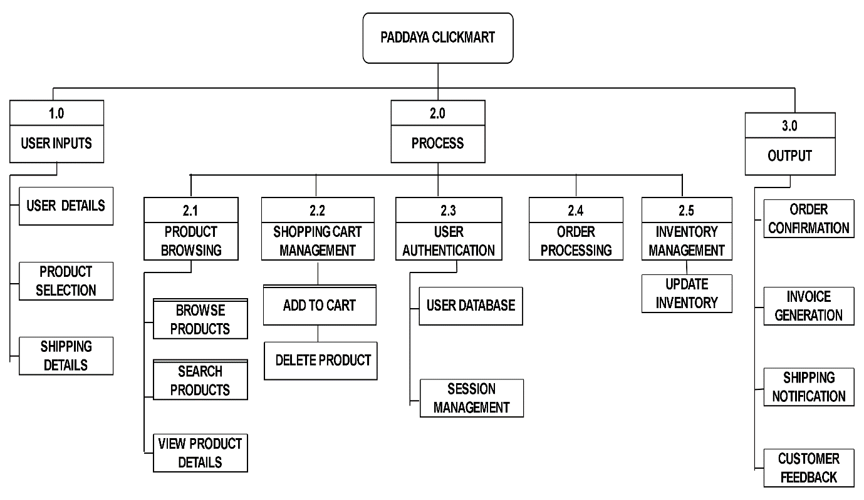

The diagram shows the hierarchical input, process, ouput at the input users provide essential details such as personal information, select desired products, and input shipping details. Subsequently, the processes within the system unfold seamlessly. Users engage in product browsing to explore the available offerings, manage their shopping carts to finalize selections, and undergo user authentication for secure transactions. The order processing stage involves the systematic handling of orders, from placement to fulfillment, while inventory management ensures accurate tracking of product availability. However, system's output are order confirmation signals to users that their purchase has been successfully received, while invoice generation provides a detailed document of the transaction. Shipping notifications keep users informed about the status of their deliveries. Additionally, the system values user feedback, fostering a loop of communication by collecting customer opinions and reviews.

Data Flow Diagram

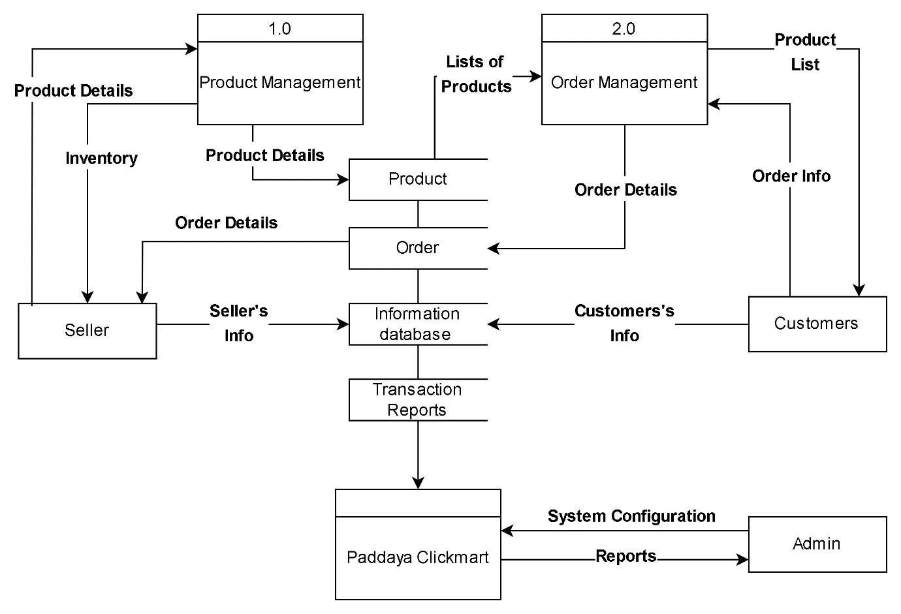

The Figure above shows the Data flow Diagram. The admin, equipped with privileged access, manages the overall functionality of the system. They handle product and user management, monitor orders, and adjust website settings. Sellers, on the other hand, register and log in to upload, manage, and process their product listings. They are responsible for overseeing their inventory and handling customer orders. Customers, the end-users, navigate the website, register, and log in to browse and purchase products.

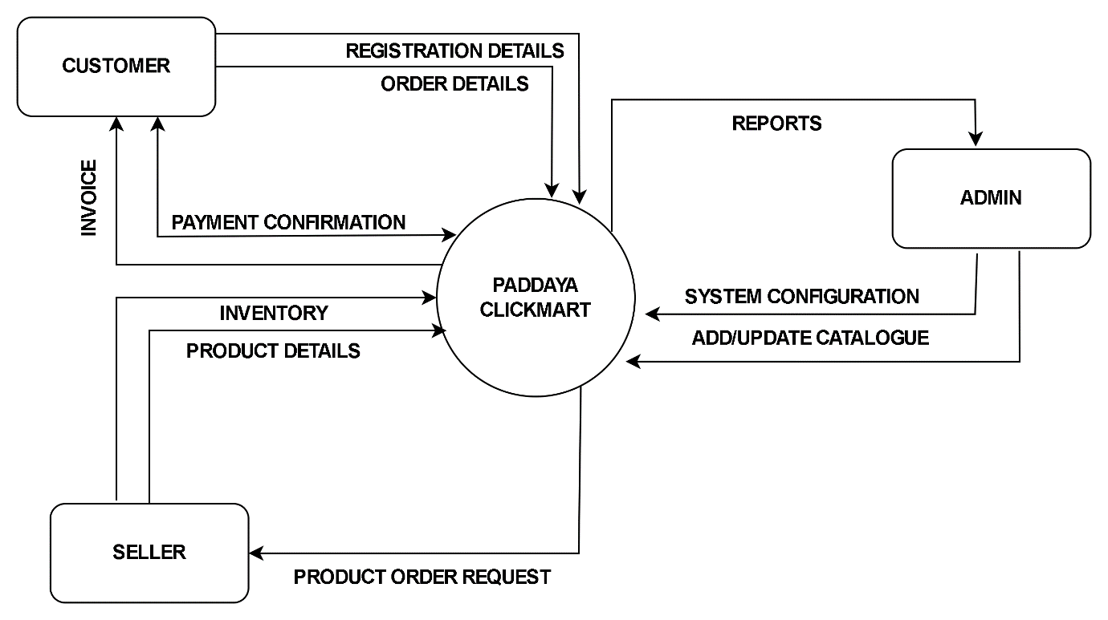
Context Diagram

The diagram illustrates the flow of the system using context diagram, customers actively participate by providing essential information, submitting registration details, and sharing order specifics. Administrator, on the other hand, they can view reports for informed decision-making, perform system configuration to ensure optimal functionality, and actively contribute to maintaining an updated product catalogue. The seller's role involves updating inventory and product details, ensuring that the product catalog remains accurate and reflective of the latest offerings.

Use Case Diagram
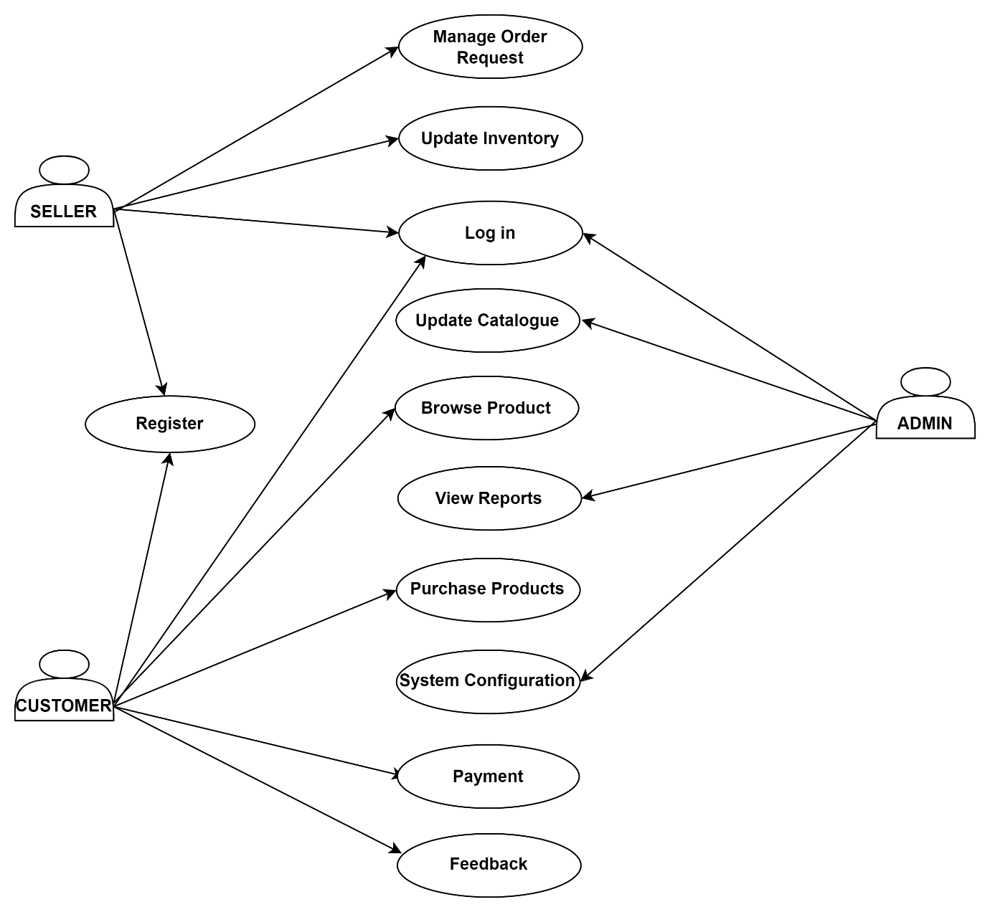
The figure depicts use case diagram, the diagram has three main actors interact within the system: Sellers, Customers, and Admins. Sellers engage in activities such as user registration, order request management, and inventory updates, reflecting their role in facilitating transactions. Customers, on the other hand, partake in essential steps of the buying process, including product browsing, purchasing, payment, and providing feedback. Admins, occupying a central managerial role, wield authority over critical system functionalities like updating the product catalogue, accessing comprehensive reports, and configuring system settings. This diagram offers a concise representation of the diverse interactions and responsibilities encapsulated in the e-commerce platform, outlining the distinct roles and actions of each participant in the system.

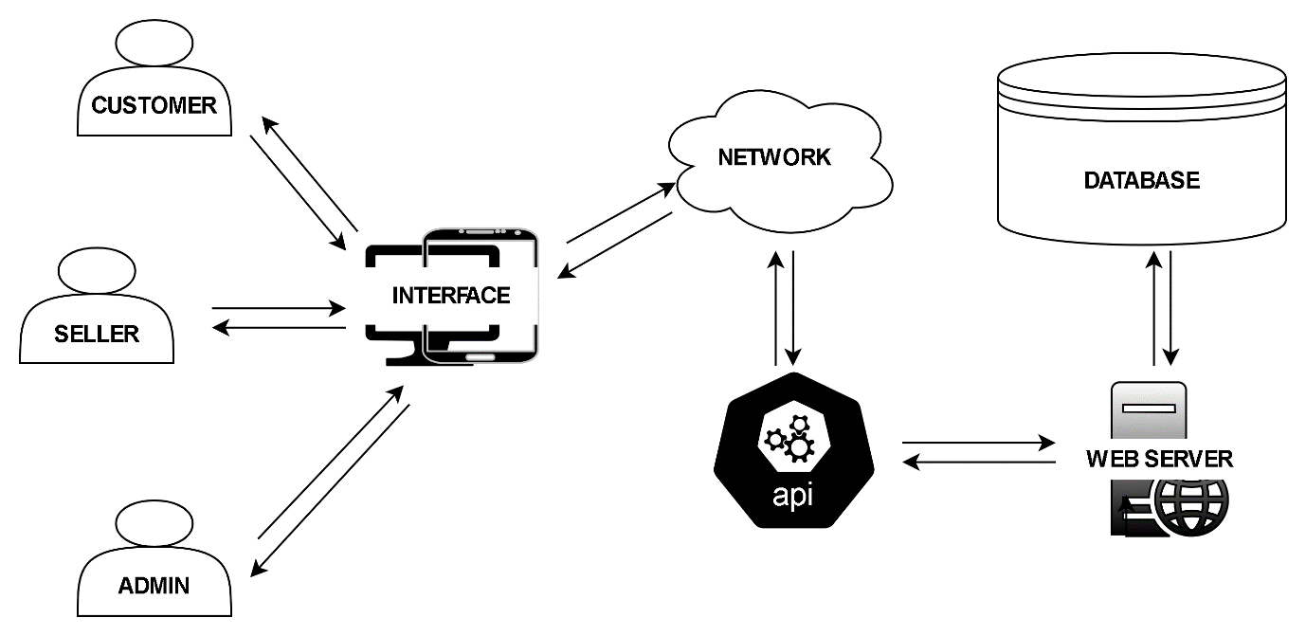
System Architecture

This figure shows the flow of the System architecture diagram. Customers, sellers, and administrators initiate actions through the user interfaces, with data flowing through a network. Application Programming Interfaces (APIs) standardize communication between interfaces and the web server. The web server manages logic and data flow, connecting to a database for storage and retrieval. The outgoing process reverses this flow, ensuring a seamless and efficient exchange of information.

Database Design
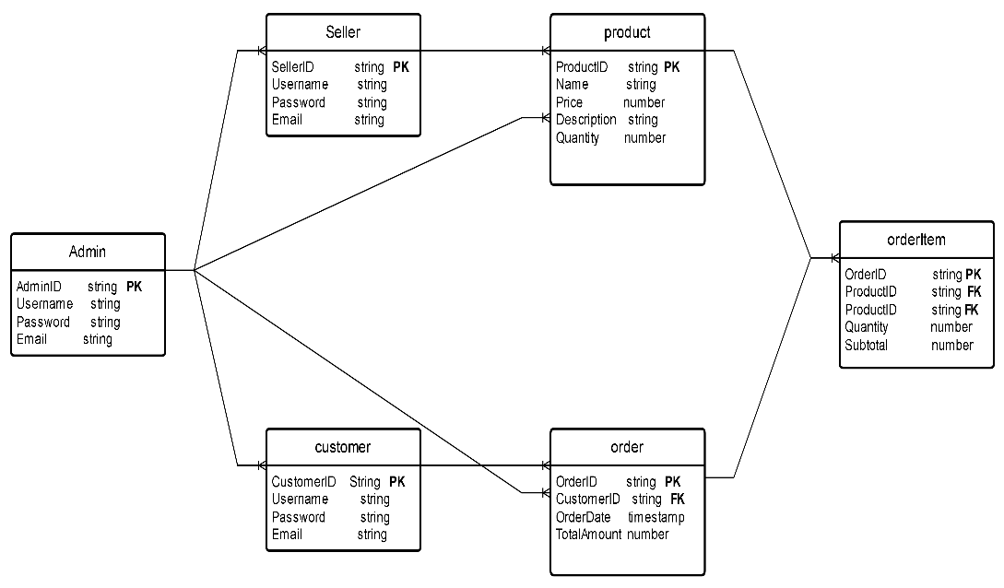

The figure shows the database design, key entities, including Admin, Seller, Customer, Product, Order, and OrderItem, each with its respective attributes. The relationships between these entities have been defined to capture the interactions within the system. Administrators, represented by the admin entity, manage Sellers in a one-to-many relationship, signifying that a single Admin can oversee multiple Sellers, but each Seller is associated with one Admin. Similarly, Sellers manage Products in a one-to-many relationship, reflecting that a Seller can handle multiple Products, but each Product is under the management of one Seller. Customers, on the other hand, place Orders in a one-to-many relationship, indicating that a customer can initiate multiple Orders, but each Order is attributed to one Customer. The Order entity is connected to OrderItem in a one-to-many relationship, denoting that an Order can consist of multiple Order Items, while each OrderItem is associated with one specific Order.

